Internship Network Learning Report

Name: Jean-Luc Twite
Department: (IT)
Company: ERG Africa
Reporting Period: Internship.
Main Supervisor: Mr Etienne & Mr Raphael Dipa.

- Introduction
This report presents an overview of the knowledge and practical skills I have acquired since I started working with the networking team at ERG Africa The objective is to clearly describe the networking concepts I have learned with the network team, and the hands-on activities I have participated in, and my understanding of the network infrastructure used within Frontier.

- Skills learned

- I have learned about the UTP (ethernet cable) and how to wire it
- I have been introducing to the different types of networks such as LAN, WAN and
VLAN
- LAN (Local Area Network): Used to connect devices within the same site or location
- WAN (Wide Area Network): Used to connect networks across long distances and to the internet
- VLAN (Virtual local Area Network): is way to split one physical NETWORK into many separate networks.

- I learned the difference between a Mac Address and IP address
- Mac address: the Mac addresses is the physical address of the device
- The IP address: is the address we get when accessing a network

- I have also learned how to install a system from the network.
- I have of how to configure the ubiquity antenna and how to place them so they can communicate each other.
- I learned about what a media converter which is convert the light energy from the Fiber optic to the electric and vice-versa

- ACTIVITIES

3.1 Wednesday, 21 January 2026 (07:00 – 17:00)
The day started with a visit to the Zambia Gate with Mr Heritier to troubleshoot an issue with an IP phone. Upon inspection, we found that the phone was powered off. We checked the UTP cable, unplugged it, and reconnected it, which temporarily restored the phone’s functionality.
After reporting the issue to the IT team, it was confirmed that the UTP cable was damaged. Mr Etienne assigned me the task of replacing the cable. I wired and connected a new UTP cable, successfully restoring the IP phone permanently.
Later in the day, after the break, I accompanied Mr Dan and Mr Etienne to the dispatch mine to splice a broken Fiber optic cable. During this task, I learned how to use a light source device to locate the damaged Fiber and identify the correct splice point.
Additionally, I learned about the radio communication system used at the dispatch department. I was introduced to both portable radios and mobile radios, their multiple channels, and how communication groups are organized, such as the load-and-haul operations.

3.2 Thursday, 22 January 2026 (07:00 – 17:00)
On this day, I worked with Mr Etienne and Mr Dan at the camp manager’s office to fix access control devices that were not functioning. We replaced a non-manageable switch with a manageable switch to support proper configuration.
After installing the new switch, we configured VLANs and assigned specific ports for the access control devices. Once the readers were connected to the configured ports, we tested the system, and the devices worked successfully.
Later, we returned to the dispatch area to organize network cables as part of housekeeping activities.
In the afternoon, we were assigned a task to provide network connectivity to the Quick Space. We configured two Ubiquiti antennas one as a master and the other as a client. The client antenna was configured to receive signals from the master. After integrating the setup into the ERG network, we connected the master antenna to the Vodacom antenna to establish external connectivity.

3.3 Friday, 23 January 2026 (07:00 – 17:00)
On this day, I was assigned to the camp manager’s club to set up a video projector. Additionally, I assisted users by installing and configuring Ivanti on their devices. The day focused mainly on user support and basic IT assistance tasks.

3.4 Monday, 26 January 2026 (07:00 – 17:00)
On this day, I went to the Labo with Mr Etienne and Mr dan to arrange the network’s cable that was giving network to the printer because it was not well placed so the network team gave me a chance to find a solution on how we can place it correctly on a proper way.
So I decided to take another cable pass it through the Rought to the lab’s network room as first option but I realised that was time consuming then I find a room near the room were the printer was, that has ethernet plugs then that where I decided to direct the cable and take network from there to give to the printer.
I had some challenges which didn’t give me enough time to wire the cable at the end of the day Mr dan and Mr Etienne came a bit later to help me to finish the work. We were to finish I helped with the housekeeping then we left.

3.4 Tuesday, 27 January 2026 (07:00 – 17:00)
On this day, I was sent by Mr Raphael to the camp manager at the club section to set up the video projectors they were a formation of a new system.
Then after we had the task to go assist some users with the installation of Ivanti mobile application I assist Mr Constantin with it.

3.5 Wednesday, 25 January 2026 (07:00 – 17:00)
On this day I was given a task to install the system on new laptops the network but unfortunately after many try, I failed to install it. It just later we realised that the SCCM server was down. After Mr Raphael gave me a task to go and install a new monitor at the project department for the new HR. And after that I supposed to power on the computer I did power it on and connecting it to the network

3.6 Thursday, 24 January 2026 (07:00 – 17:00)
On this day I went with Mr Heritier to the Quich space to assist him to place the client antenna and power it on. Then i went back the Vodacom antenna with Mr Etienne, dan, Heritier to fix the master antenna that was set to send signal to its client so that we can bring connection to the Quick space.
Then after we went back to the mining office with Mr dan where he shows and explains the ERG-Africa frontier mine’s network infrastructure.
Below it is small architectural design.
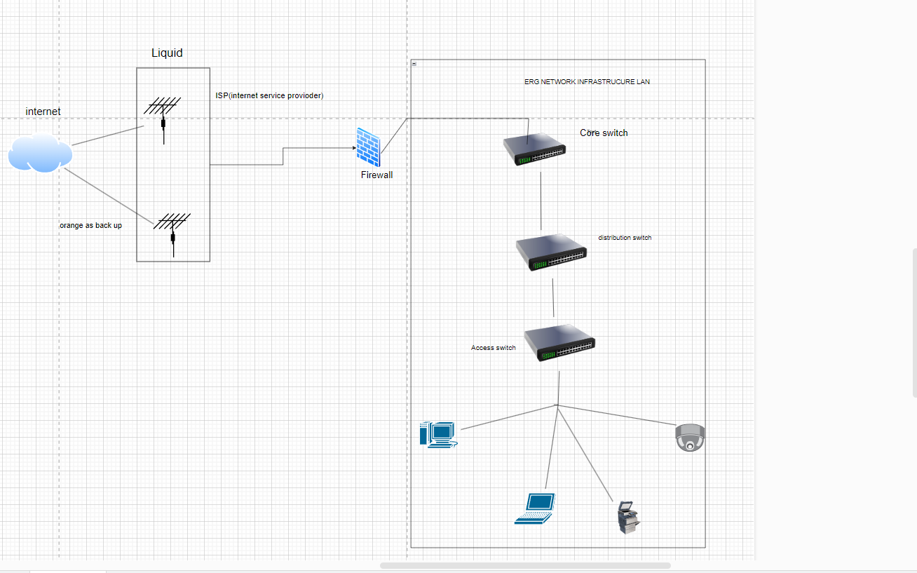

- Observation and challenge:

- While I was wiring for the first time the ethernet cable for the Ip phone at the Zambia gate I gave to Mr Etienne a timeline. Of when the replace and the wire of the cable will be done but unfortunately I didn’t finish on the timeline I gave due the challenges I face such as I had issues to align the coppers wires inside the ethernet cable I did it twice then I decide to have a look on the internet then align them based on what I got from the internet then I was able to wire successfully the UTP cable and bring network back to the Ip phone.

- The second challenge is about installing a system from the network which was also my first time. after I failed for the first time I rush to the second without even think why it failed it after many times that I realise the SCCM server was down.

- Conclusion

With the help of the network team I have learn a lot from someone who didn’t have any Hand-on experience when it comes to the network with the team network at erg Africa help me to understand how network work learning first how to wire an ethernet cable which, I Have been explain on how VLAN work looking forward to learn how to configure VLAN on the switch, I Have only see how the splicing of the Fiber optic cable happen and I would like to do also some practical and Mr. dan show me a small overview of how the ERG Africa frontier mine works I have attached the small copy of the design as I am still with the team network on my journey during my internship. I can’t wait to learn and to face more the challenges coming in the network world.

